**Rest API Framework**

* Designed a Rest API testing framework using **MAVEN** as build management tool and added relevant dependencies in pom.xml file :- io.rest.assured, org.apache.poi, org.testng, org.json etc, below is the screenshot of pom.xml file.

**<groupId>com.restapiframework</groupId>**

* **<artifactId>restapiframework</artifactId>**

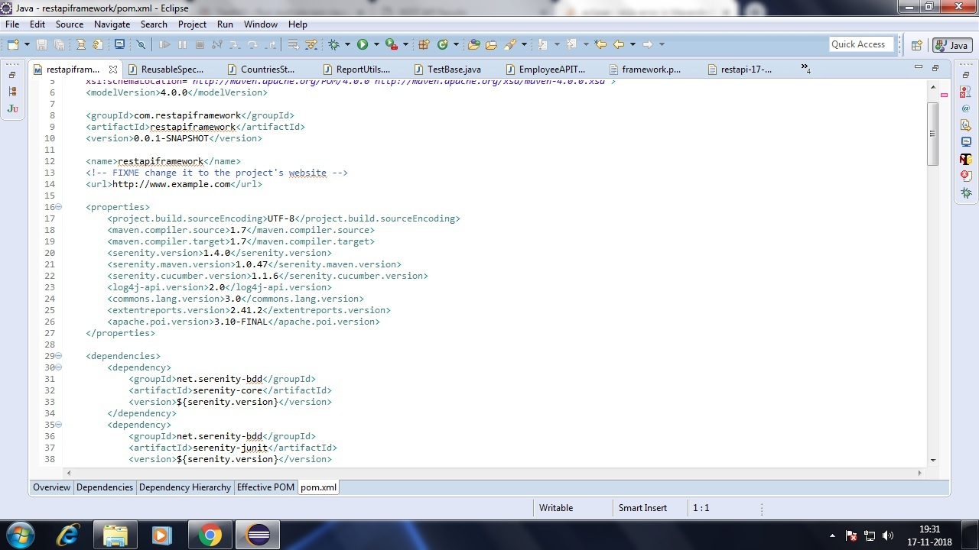

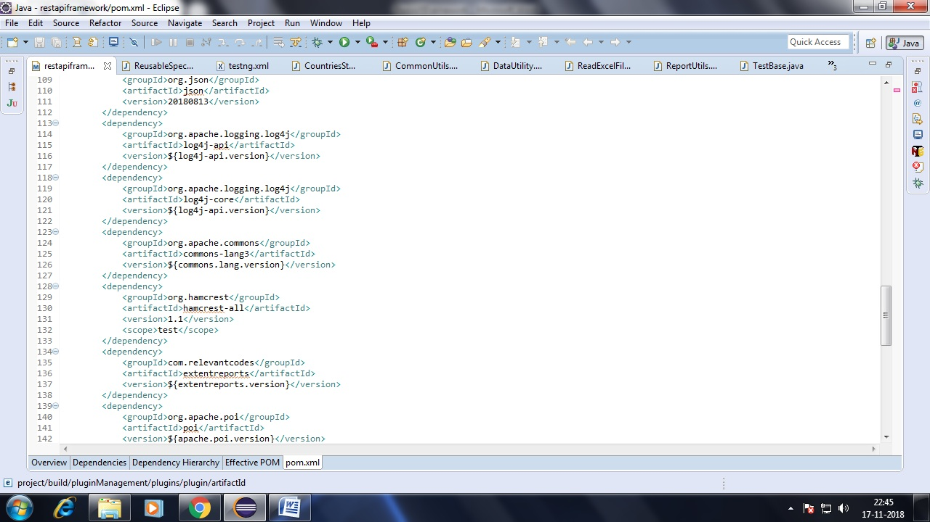

* Below is the segregation of source code.  
  i) **src/main/java** -> This Source package contains code related to common functionalities, reporting utils, data utils etc   
  iI) **src/test/java** -> This Source package contains code related to TestBase class, rest api related test cases.  
  iii) **src/test/resources** -> This Source package contains test data excel files, extent test reports generated after each rest api test case run, log4j.xml file, framework.properties file which are utilized in rest api automation.

iv) **src/main/resources** -> This Source package contains extent test config xml file.  
v) **logs** -> This folder contains dynamically generated log files after rest api test cases are run.  
vi) **testng.xml** -> This xml file contains rest api test cases classed to run as suite.

* Below screenshot is of framework folder structure and testng.xml file to run rest api test cases as suite.

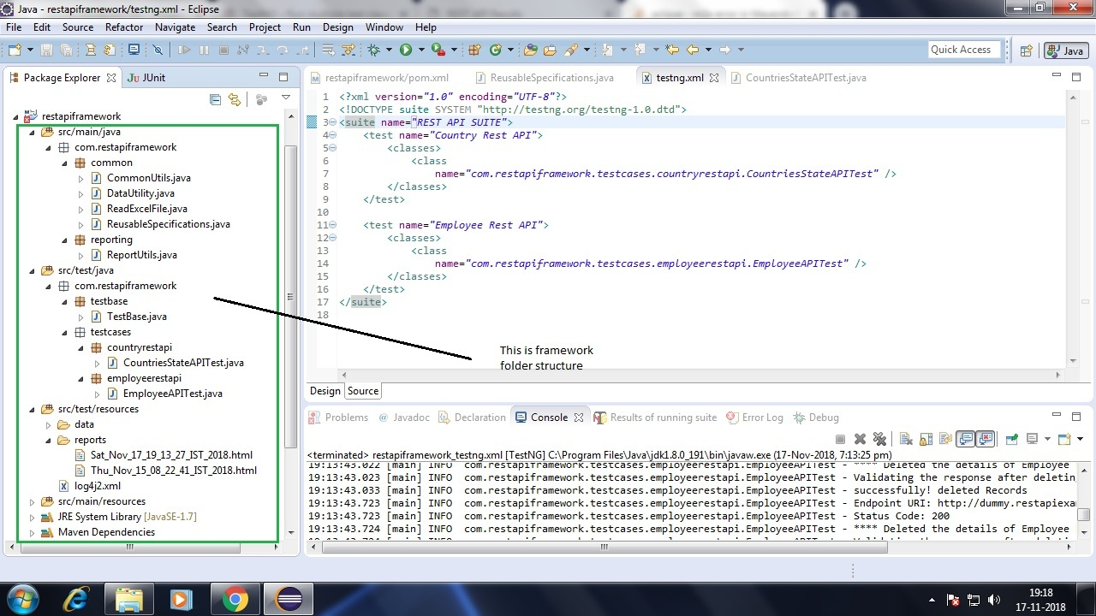

* Below screenshots are of **common.CommonUtils** class and properties (to read **base URI**) which contains code related to common functionalities as **read data from properties file** etc.

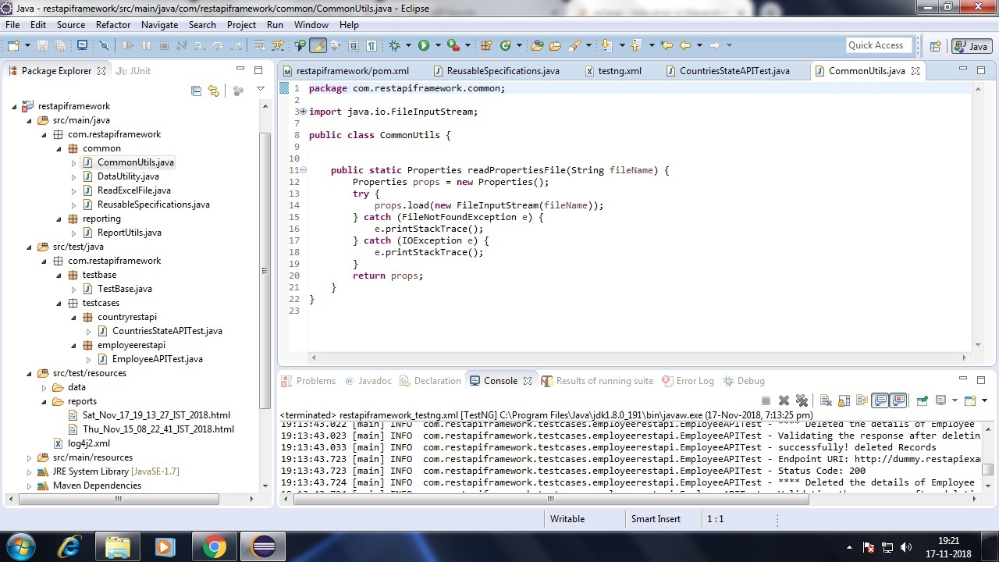

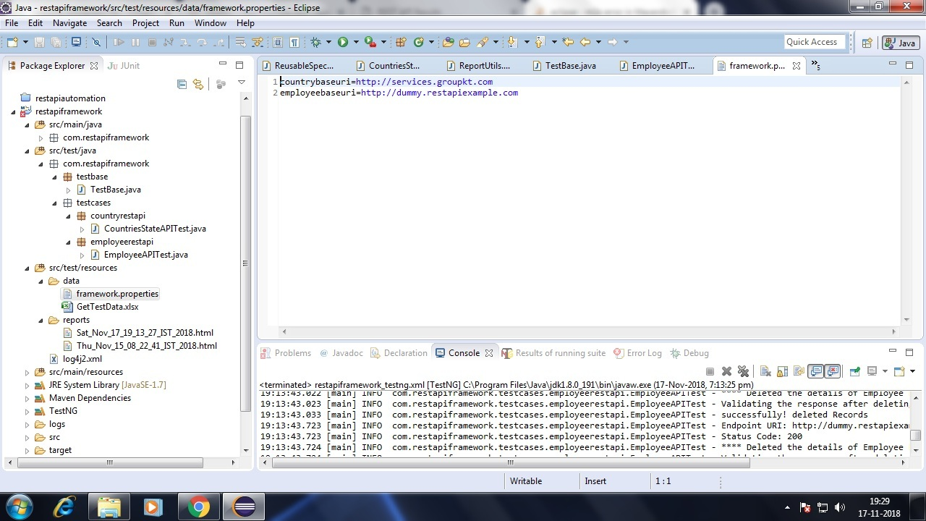

* Below screenshots of **common.DataUtility, common.ReadExcelFile** (reusable methods) and test data excel files, contains code related to **get data from excel file** provided excel file and sheet name.

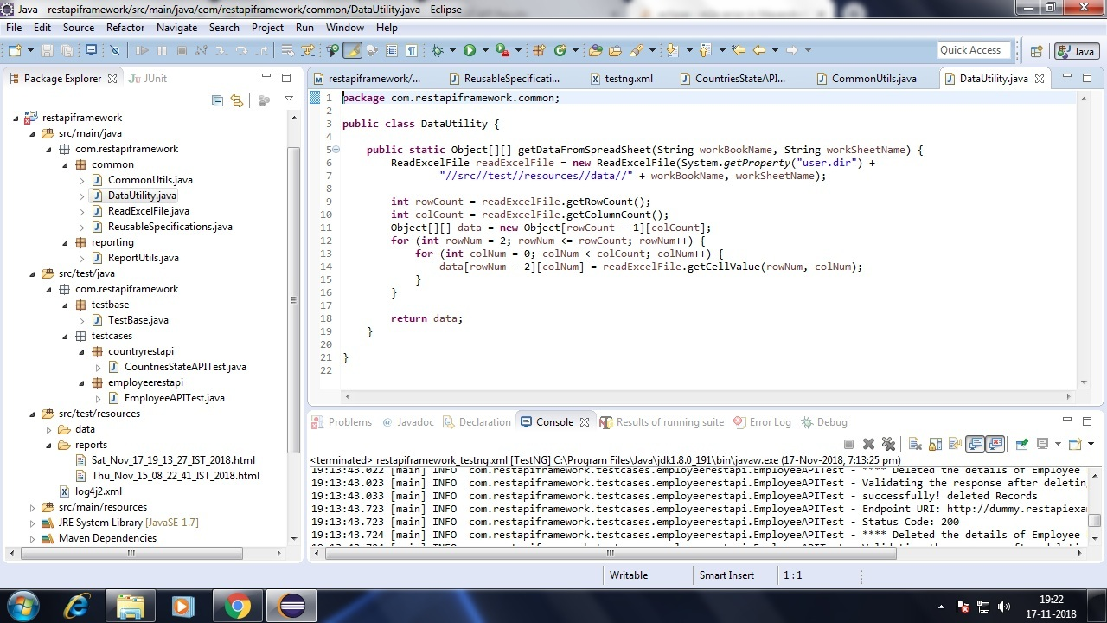

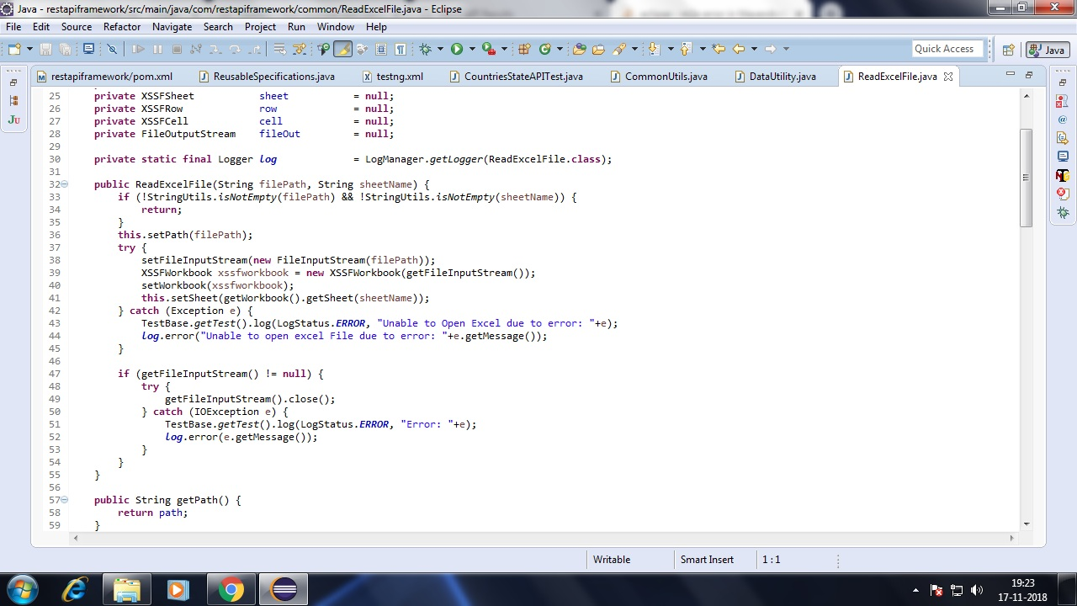

* **Countries Test Data excel file**

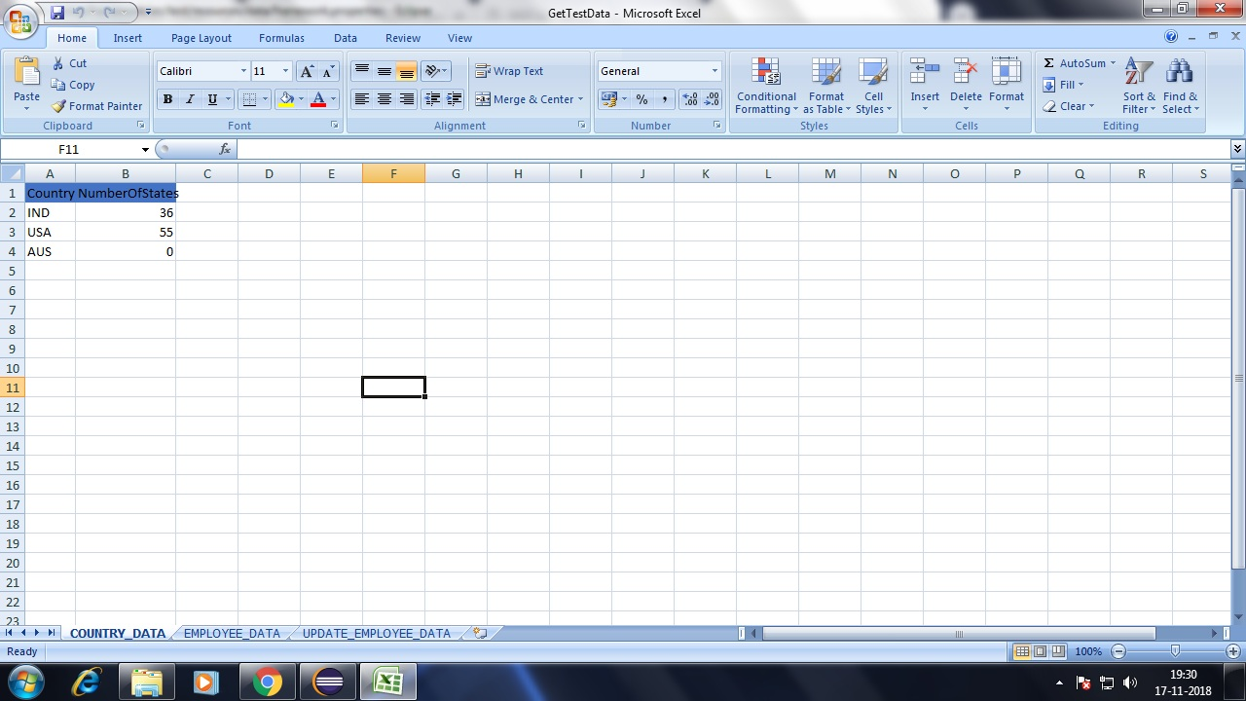

* **EmployeeTest Data Excel file**

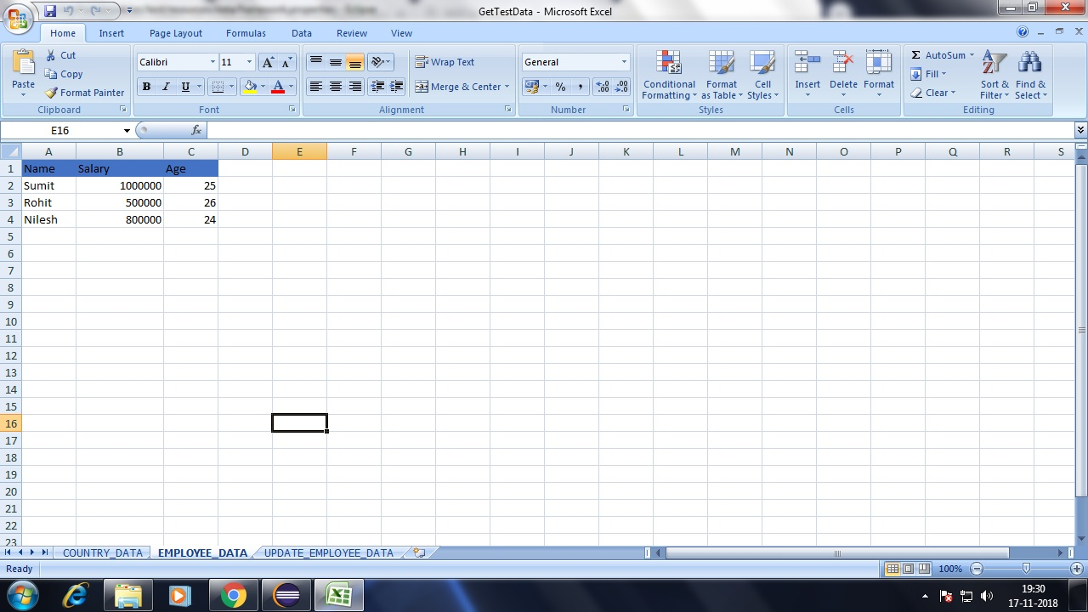

* Below Screenshot is the code of **common.ReusableSpecifications** this class contians code related to **Request and Response specifications** and used when rest api call is triggered.

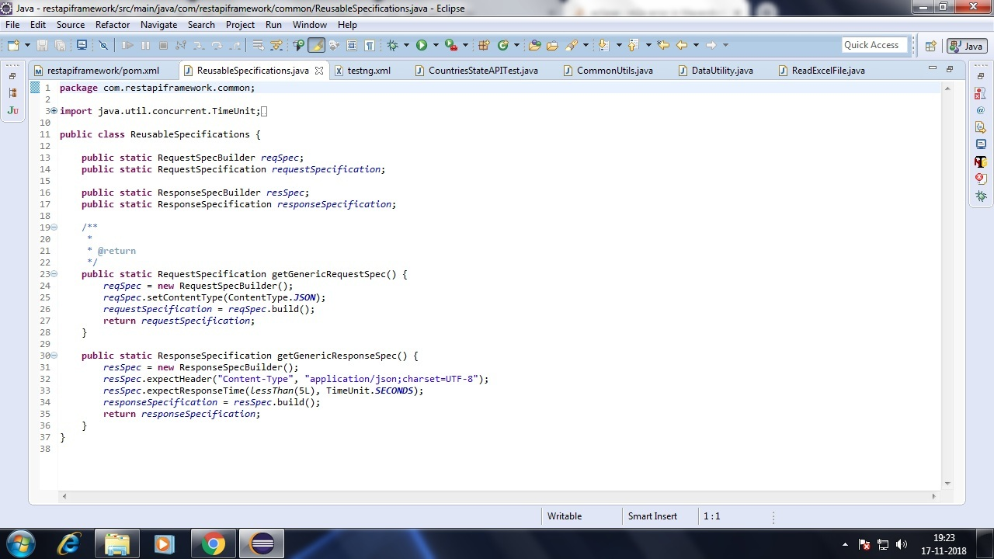

* Below Screenshot is **common.ReportUtils** class this contains code related to extent test report configuration and **generate extent test report after each rest api test case run.**

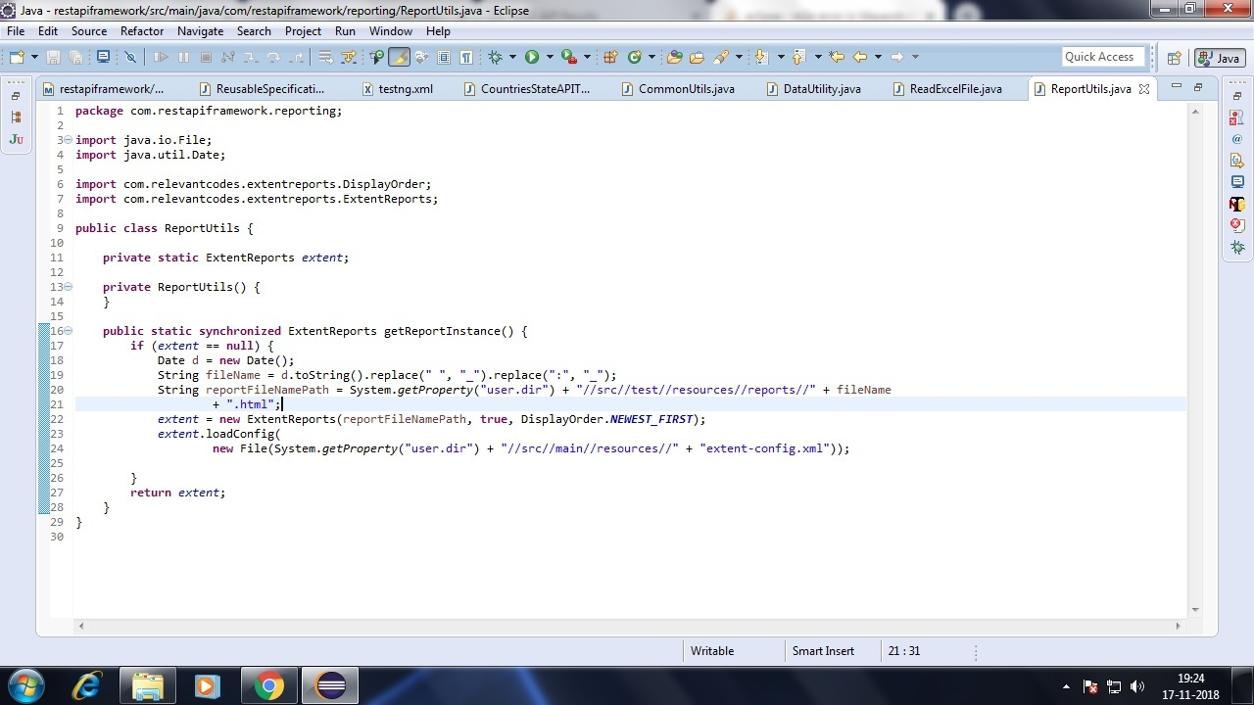

* Below screenshot contains code related to **src/test/java, testbase.TestBase** class contains code related to start extent test report in @BeforeMethod and end test in@AfterMethod and reusable method to write log in both extent test report as well as in .log file.

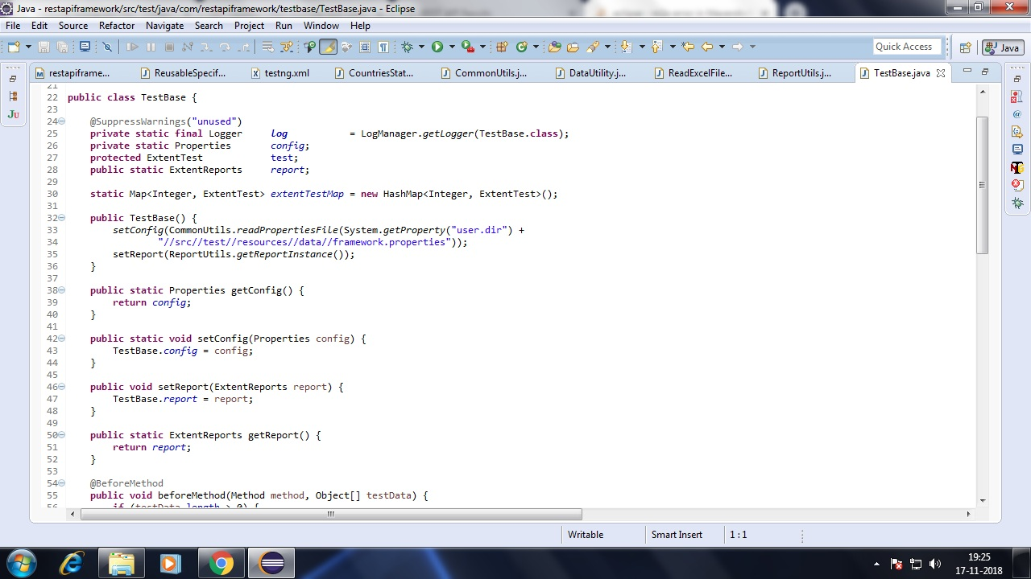

* Below screenshot contains code related to **testcases.countryrestapi.CountriesStateAPITest** class code to test http://services.groupkt.com/state/get/{Country} Rest API and validation (**Reading Data from GetData > COUNTRY_DATA excel file**)

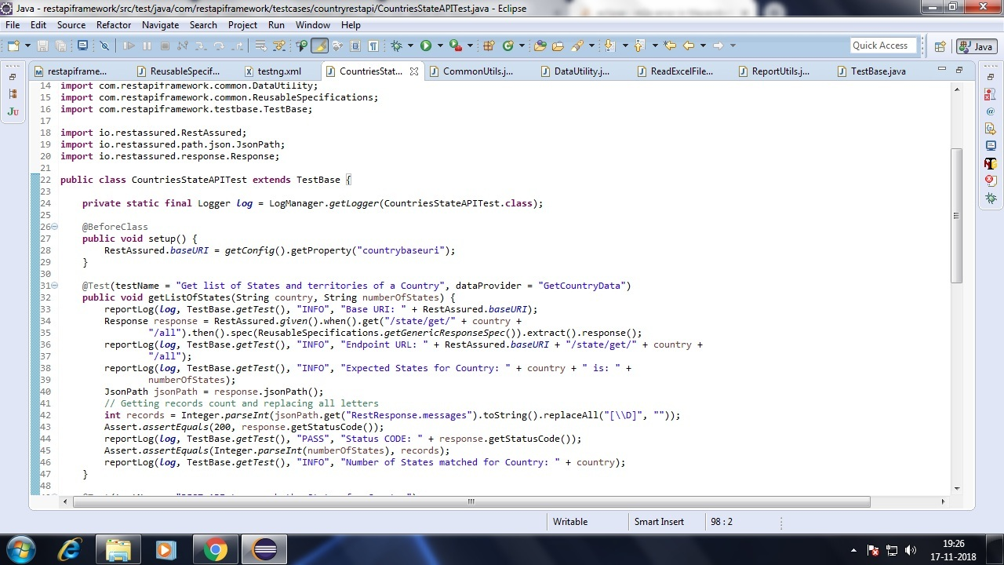

* Below screenshot contains code related to **testcases.countryrestapi.CountriesStateAPITest** class code to test http://services.groupkt.com/ state/get/{Country}/{State} Rest API and validation and get states of Country

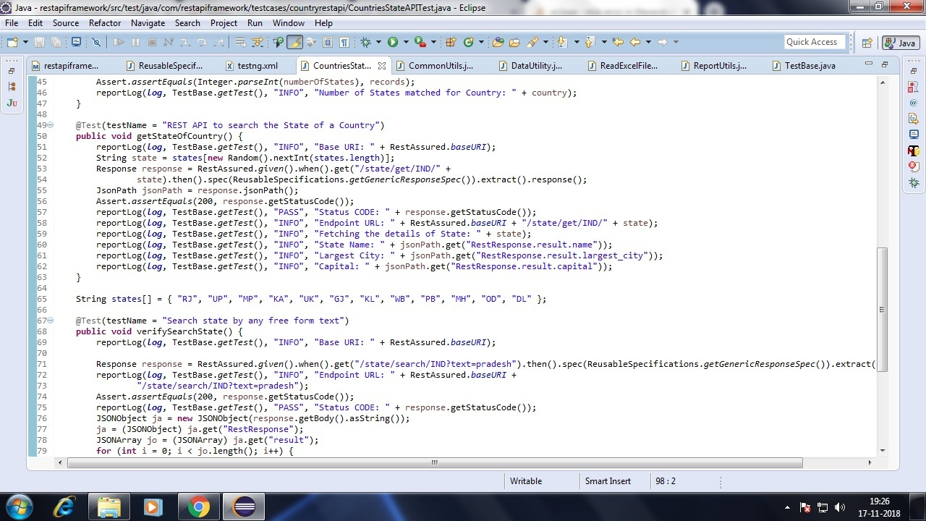

* Below screenshot contains code related to **testcases.countryrestapi.CountriesStateAPITest** class code to test http://services.groupkt.com /state/search/{Country}?text={inputText} Rest API and response validation of found states for input country

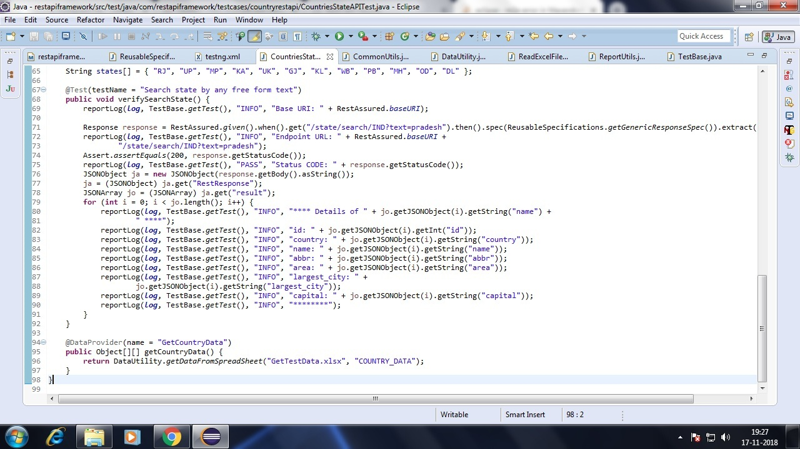

* Below screenshot contains code related to **testcases.employeerestapi.EmployeeAPITest** class code to test http://dummy.restapiexample.com /api/v1/create Rest API and **POST method to create employee (Reading Data from Get data > EMPLOYEE_DATA excel file).**

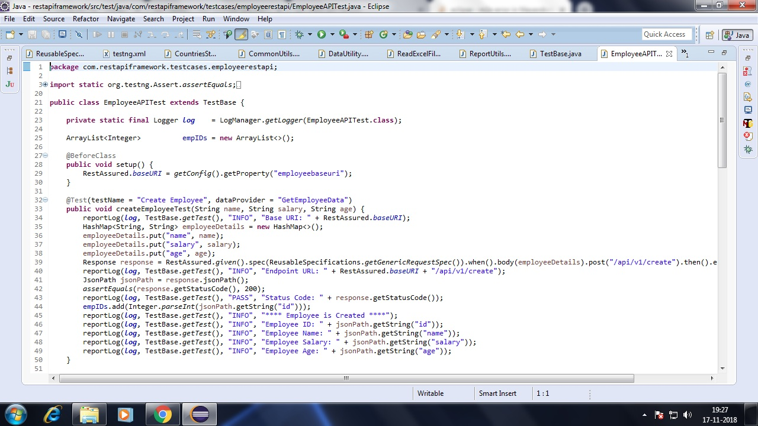

* Below screenshot contains code related to **testcases.employeerestapi.EmployeeAPITest** class code to test http://dummy.restapiexample.com /api/v1/employee/{employeeID}Rest API and **GET method to get employee details by providing employee ID.**

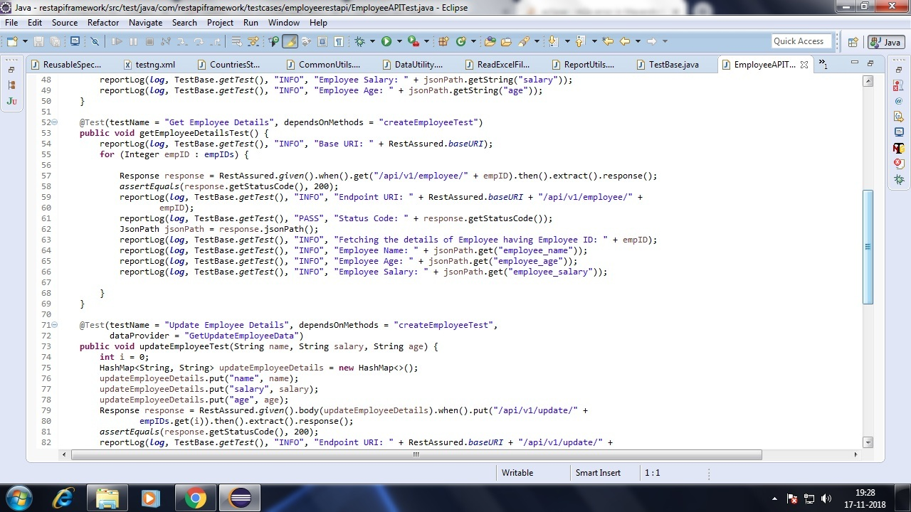

* Below screenshot contains code related to **testcases.employeerestapi.EmployeeAPITest** class code to test http://dummy.restapiexample.com /api/v1/update/{employeeID} Rest API and **PUT method to update employee details (Reading Data from Get data > UPDATE_EMPLOYEE_DATA excel file).**

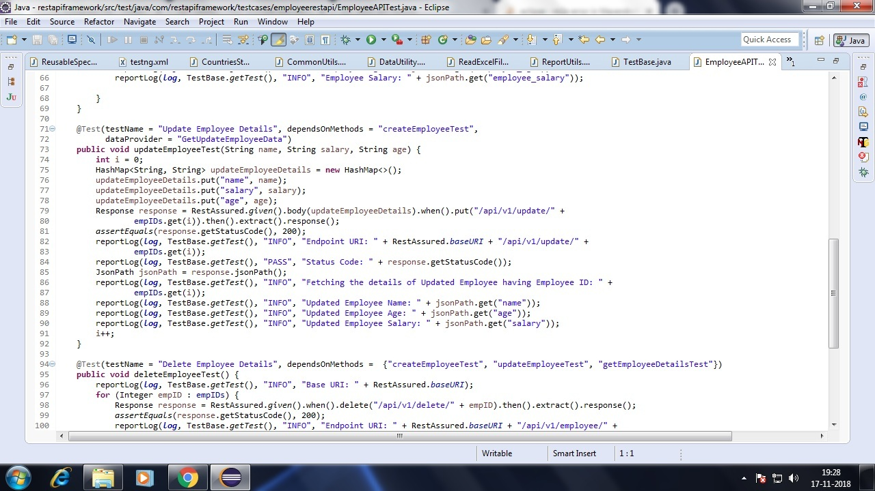

* Below screenshot contains code related to **testcases.employeerestapi.EmployeeAPITest** class code to test http://dummy.restapiexample.com /api/v1/delete/{employeeID} Rest API and **DELETE method to delete employee details by providing employee ID.**

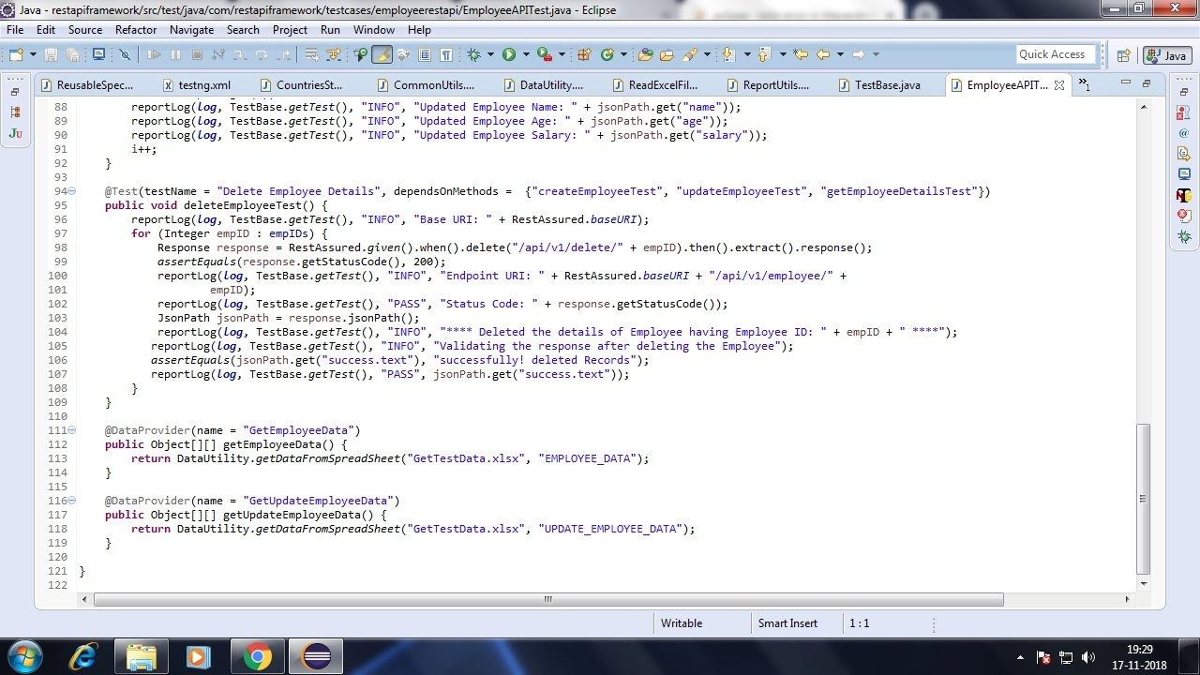

* Below Screenshot of source folder **src/test/resources** contains **extent test reports** and **log4j.xml file**

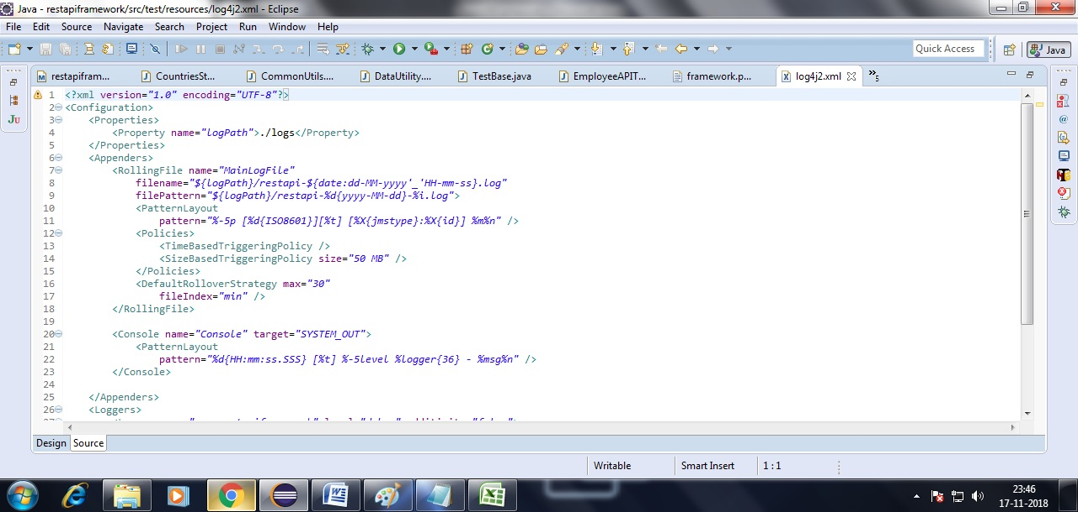

* **Screenshot of Extent test report generated after REST API Test cases run (Employee REST API Results)**

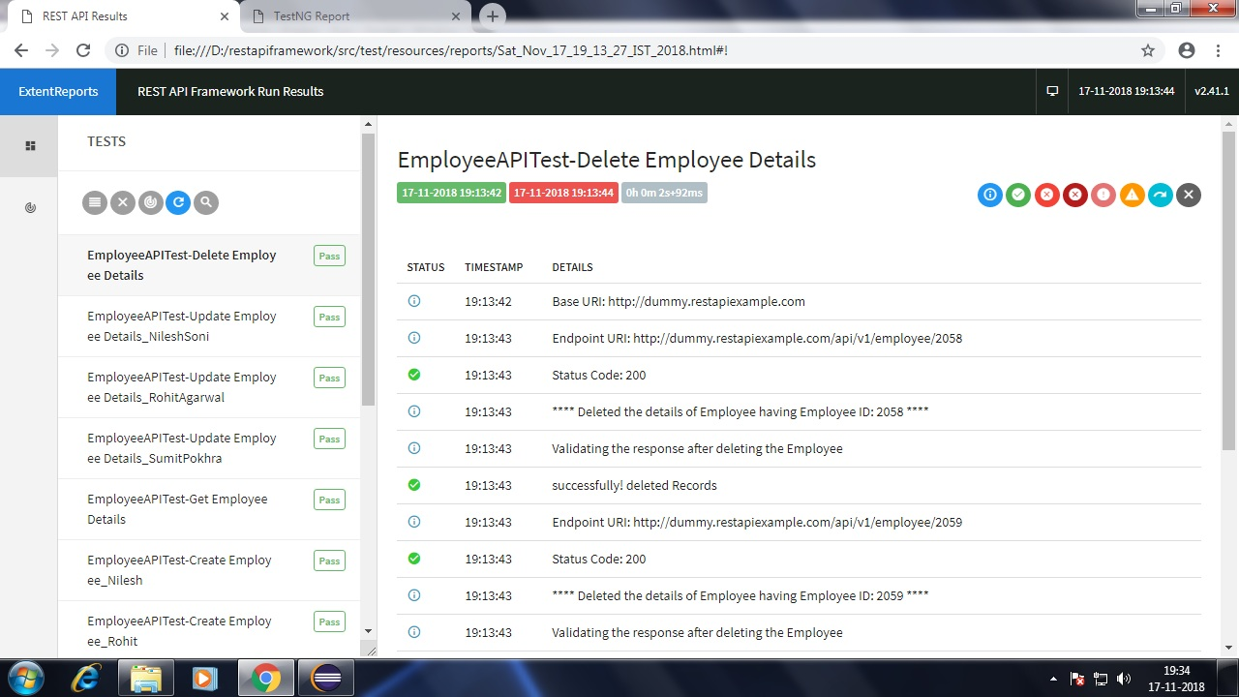

* **Screenshot of Extent test report generated after REST API Test cases run (Countries REST API TEST Results)**

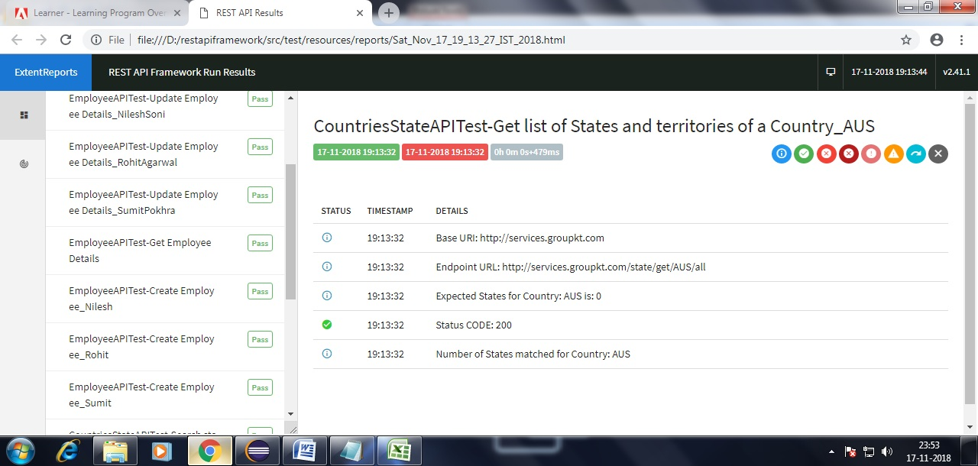

* **Screenshot of Extent Test Dashboard.**

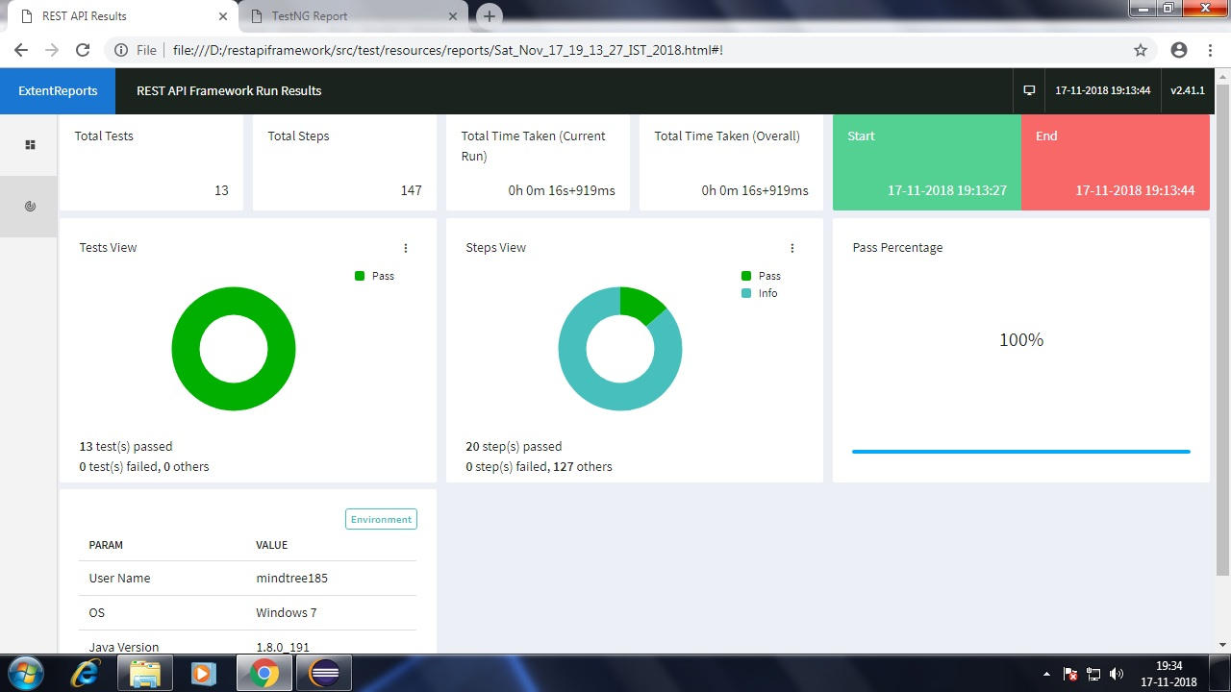

* **Below Screenshot is of logs generated dureing REST API test cases run.**

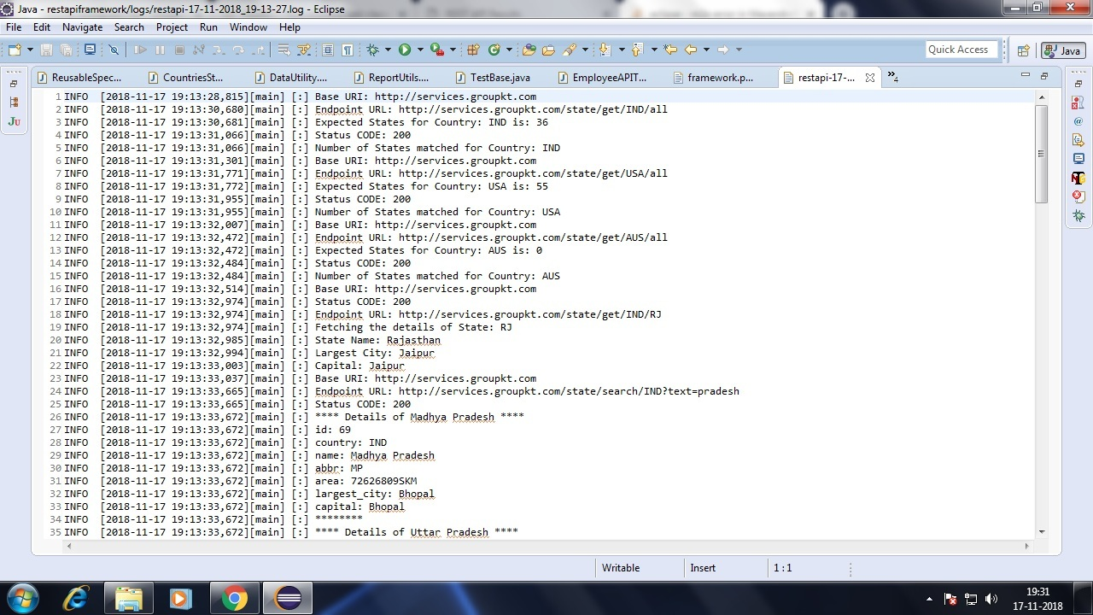

* **Below Screenshot is of TestNG methods results.**

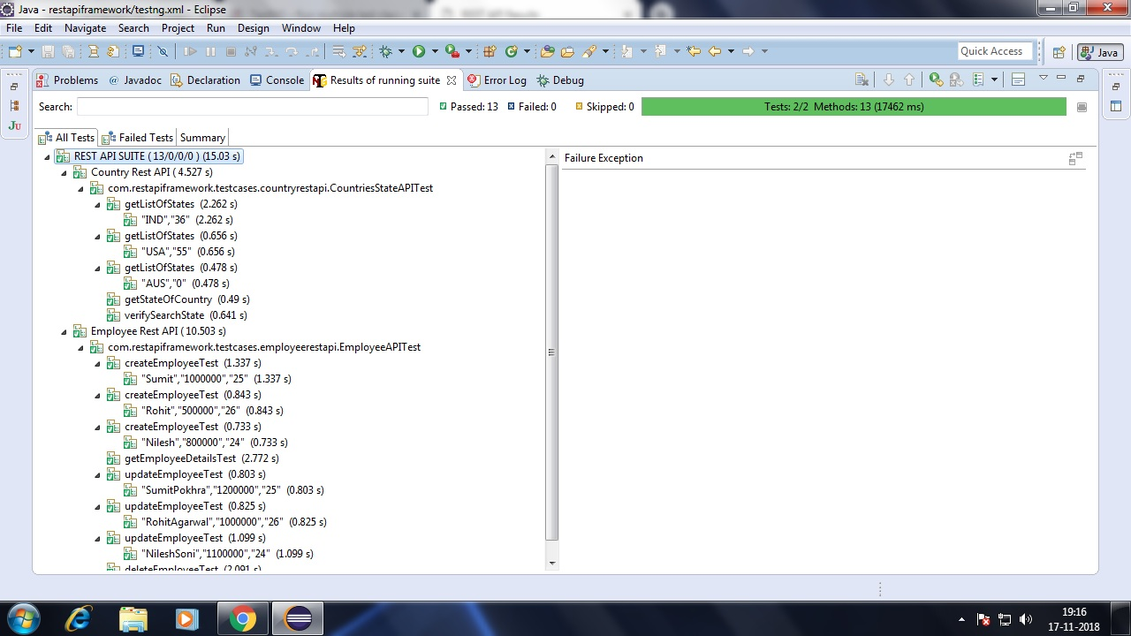

* **Below screenshot is of TestNG generated emailable-report.html (Country REST API and Employee REST API)**

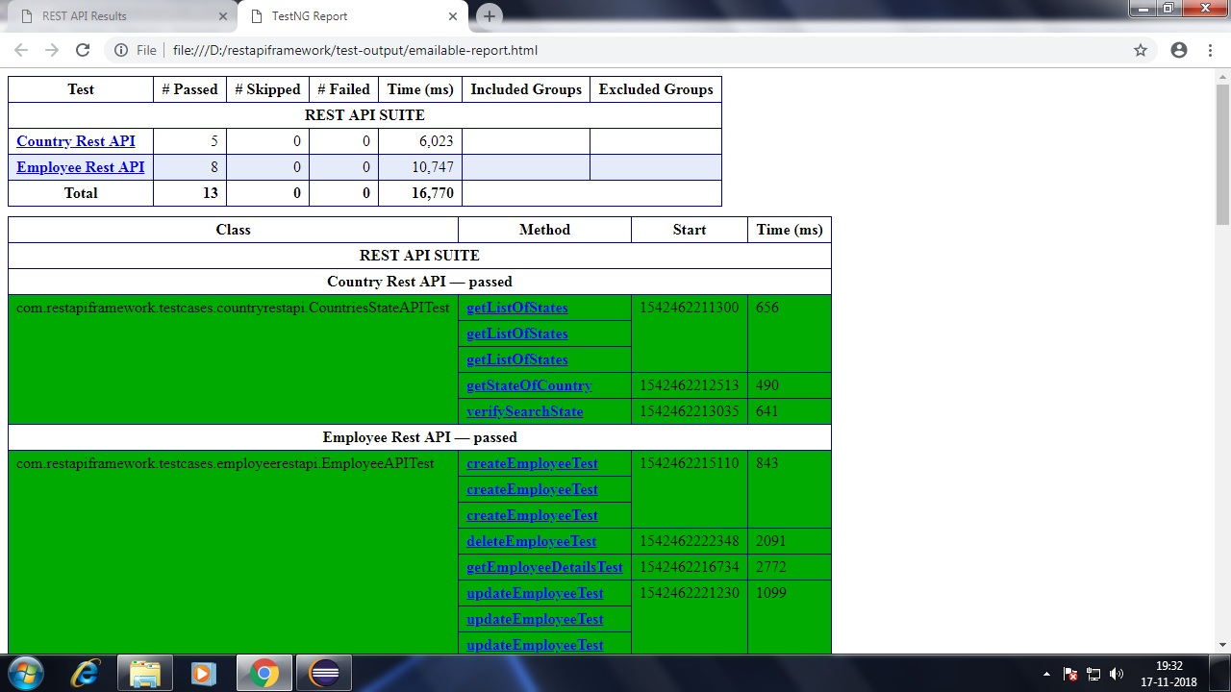

* **Below screenshot is of TestNG generated emailable-report.html (Country REST API with Parameters)**

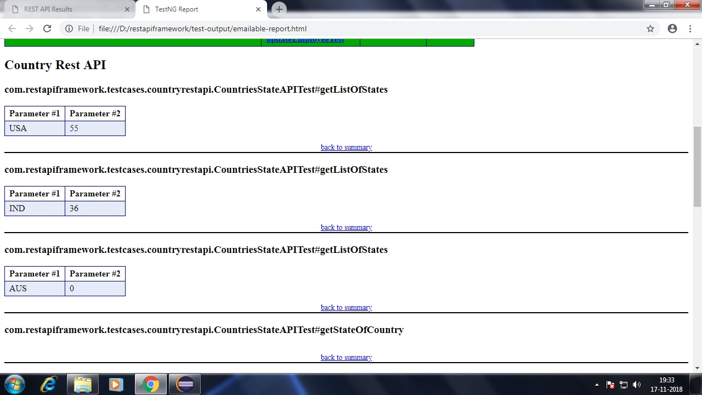

* **Below screenshot is of TestNG generated emailable-report.html (Employee REST API with Parameters)**

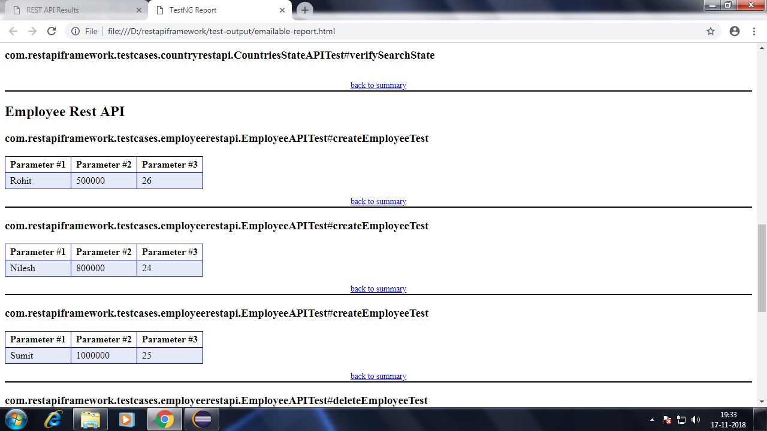

**Framework Designed BY:  
Sumit Pokhra   
Senior Test Automation Engineer  
(Mindtree LTD.)**